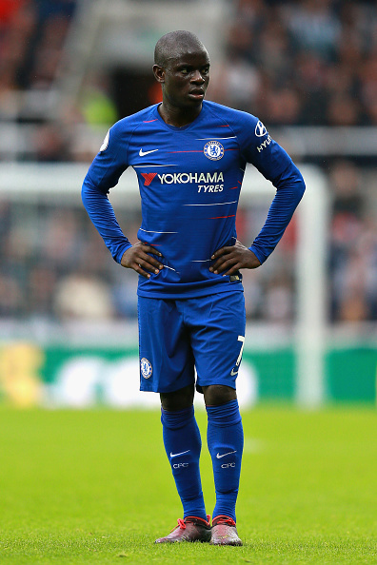**What tgm students may learn from N’Golo Kanté**

**Biography**:

Kanté was born on 29 March 1991 in Paris (France) to parents who earned their income by collecting refuse and cleaning. He, too collected garbage to support his family. He knew very well that remaining in this occupation would not get his family out of poverty, so he started looking for alternatives that would provide him with the financial freedom and future for himself and his family. At the age of 8, he started his football career.

He first played with JS Suresnes. His hard work brought him to Boulogne, where he played between 2010-2012. Kanté's dream of playing for an English club was later realized when Steve Walsh presented Kanté to the Premier League Club Leicester City. On 3 August 2015, he signed a four-year contract with Leicester.

He was the major factor for the club to win the Premiere League 2015/16. Kanté was the most important player who defended and attacked from his midfielder`s position.  In April, he was one of four Leicester players named in the PFA Team of the Year. The PFA award is given to a set of 55 footballers across the top four tiers of men's English football. When he left Leicester, they were not able to find an equally skilled midfielder to replace him. On 16 July 2016, Kanté signed for Chelsea. On October 2017, Kanté was nominated for the Ballon d'Or.

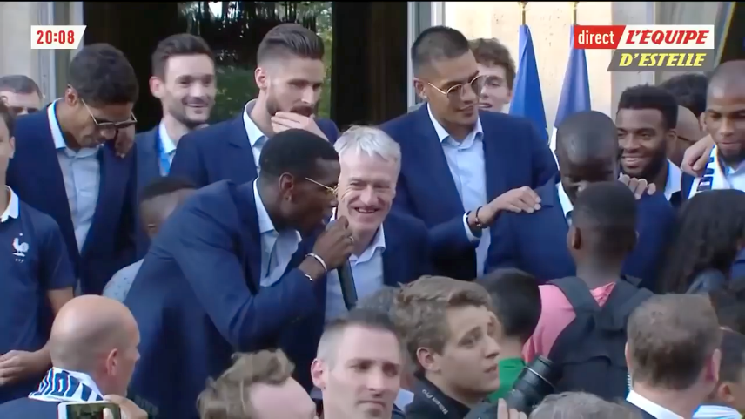His international career is also really impressive, together with Pogba he was one of the pillars of the French national team at the championship.

When France became world champion, even the president sang the ["Kanté song".](https://www.youtube.com/watch?v=hiYzWKkaODg)

**Why is Kanté** **such an important player?**

Many recognize the value of the defensive midfielder only at the second glance. He keeps the striker's back free. Kanté blocks attacks, steals balls in an incredible way. And he is everywhere on the pitch, because he runs a lot. His Chelsea teammate Eden Hazard said of Kanté that he “sometimes thinks there are two Kantés on the pitch, one on the left, one on the right, N'Golo and his twin.”

Kanté gets the whole game moving. He is something like the power center of the team. He brings the balls forward and defends the goal. For example, a defender shot the ball high to the front. The ball is on the way for about two seconds. During these two seconds hardly anything happens, almost all field players look after the ball, nearly no one is in motion. Kanté, however, looks at the ball and sprints towards the ball – fans have uploaded a number of [analyses](https://www.youtube.com/watch?v=omfjlv7wxl0) of his impressive game on social media platforms.

**Why does every team need a player like Kanté?**Most coaches will build their teams around top strikers. But what is the good of having top strikers when they never get the ball? That is why you need a player like Kanté. He delivers the ball to the strikers and they can score a goal. He motivates the team to play better and does everything so that his team will win. He is everywhere on the field, he gets the balls, defends the goal – he is a player who never gives up.



**Find facilitators, …**

In business management, these people are termed “facilitators” and it is they who contribute most to a team`s success even though they might not be in the limelight. In fact, some – like N`golo Kanté – prefer to staying in the background. So next team you need to build a project team for a lab or even your diploma project in the final year, search for a facilitator – or better still, be one!

**… rather than showmen**

The picture shows Kanté, whose teammates celebrate his trophy – while he remains modestly in the background. Note how tiny he was compared to some of his teammates, despite his physical disadvantages he was the strongest player on this team. Fans have published a number of anecdotes around his humble and unassuming character, rather unusual in a media business such as football.